**Development of High Strength Concrete**

***A Project Report Submitted***

***in Partial Fulfilment of the Requirement for the Degree of***

***Bachelor of Technology***

***in Civil Engineering***

**Submitted by**

**Ahwang L Konyak (2020101105)**

**Avinash Kumar (2020101111)**

**Peeyush Katiyar (2020101127)**

**Suman Saurabh (2020101133)**

**Under the supervision of**

**Dr. Pankaj Kumar**

**Assistant Professor**



**Department of Civil Engineering**

**National Institute of Technology Nagaland**

**Chumukedima-797103**



**National Institute of Technology Nagaland**

**Statement of Originality**

Title**: Development of High Strength Concrete**

Degree for which the thesis is submitted: B. Tech Civil Engineering

We do hereby declare that the matter presented in this thesis largely represents our own ideas and work in our own words. Where others’ ideas or words have been included, we have adequately cited and have been duly referenced. There is no plagiarism or data falsification/fabrication in the thesis. We also declare that we have adhered to all principles of academic honesty and integrity.

**Ahwang L Konyak (2020101105)**

**Avinash Kumar (2020101111)**

**Peeyush Katiyar (2020101127)**

**Suman Saurabh (2020101133)**

**NIT Nagaland**



**National Institute of Technology Nagaland**

**Certificate**

This is to certify that the report entitled “Development of High Strength Concrete.” submitted by Ahwang L Konyak (2020101105), Avinash Kumar (2020101111), Peeyush Katiyar (2020101127) & Suman Saurabh (2020101133) of National Institute of Technology Nagaland has reached the requisite standard fulfilling the requirement for the award of the degree and is worthy of consideration for the degree of Bachelor of Technology in accordance with the regulations of this institute. The results contained in this thesis have not been submitted in any other university/institute in part or full for the award of any degree or diploma to the best of my knowledge and belief.

**NIT Nagaland**  **Dr. Pankaj Kumar**

**Date: Assistant Professor**

**Department of Civil Engineering**



**National Institute of Technology Nagaland**

**Acknowledgement**

First and foremost, we would like to thank the Almighty God for His unending favour and assistance in enabling us to do our project on **“DEVELOPMENT OF HIGH STRENGTH CONCRETE.”** Efforts have been made on this project. However, without the generous support and assistance of many people, it would not have been feasible. We want to express our sincere gratitude to each and every one of them.

We owe a great deal to Dr. Pankaj Kumar, Assistant Professor of Civil Engineering at NIT Nagaland for his guidance and constant supervision as well as providing necessary information. We express our sincere gratitude for his generous assistance and help with the project. His continual assistance and willingness to share his enormous experience made us comprehend the project and its manifestation in great depth and helped us finish the allocated task on time.

Lastly, we would like to thank our family and friends who have rendered their support and prayers during our journey.

**NIT NAGALAND**  **Ahwang L Konyak 2020101105**

**Date: Avinash Kumar 2020101111**

**Peeyush Katiyar 2020101127**

**Suman saurabh 2020101133**

**Abstract**

The evolution of concrete technology has been marked by rapid advancements since its inception. With an increasing reliance on concrete for infrastructure projects, addressing challenges posed by severe conditions, chemicals, and thermal stresses is imperative. High-strength concrete, crafted meticulously through the selection of premium materials and precise mixture designs, offers resilience. Optimal results are achieved with crushed rock aggregates of 10 to 20 mm size, exhibiting a balance between smoothness and shape. Bond strength between smaller aggregates surpasses that of larger ones, making smaller aggregates preferable.

The key to high-strength concrete lies in the water-cement ratio, where maintaining a low ratio is crucial. Employing a low water-cement ratio necessitates the use of polycarboxylate-ether based superplasticizers. It is essential to leverage superplasticizers for maximum water reduction, particularly for higher strength requirements. Merely increasing cement content may not guarantee enhanced strength, as there exists an optimum range of 450 to 550 Kg/m3 for total cementitious materials. The proportioning of high-strength concrete aligns with standard practices, aiming for a cohesive mix with minimal voids. This can be achieved through theoretical calculations or empirical laboratory trial.

Keywords: ratio; strength; admixtures; mix design; workability

**List of Figures**

|  |  |  |
| --- | --- | --- |
| ***Fig no.*** | ***Name of figure*** | ***Page no.*** |
| ***01*** | ***High rise building*** | ***04*** |
| ***02*** | ***Bridge*** | ***04*** |
| ***03*** | ***Parking Structure*** | ***05*** |
| ***04*** | ***Industrial Structure*** | ***05*** |
| ***05*** | ***Dams and reservoir*** | ***06*** |
| ***06*** | ***Marine structure*** | ***06*** |
| ***07*** | ***Powerplant*** | ***07*** |
| ***08*** | ***Precast concrete elements*** | ***07*** |

**Table of Contents**

**STATEMENT OF ORIGINALITY………………………………………………… ii**

**CERTIFICATE……………………………………………………….………………. iii**

**ACKNOWLEDGEMENT……………………………………………………………. iv**

**ABSTRACT…………………………………………………...………………………... v**

**LIST OF FIGURES……………………………………………………………………Vi**

**Chapter 1 INTRODUCTION………………….……………………….…………1-16**

**1.1 Concrete……………………………. …..……………………….................. 1**

**1.2 Special Purpose concrete………………………………….….................... 1**

**1.3 Types of Special Purpose concrete …………….…….….………………. 1**

**1.4 High strength concrete………………. ...………..…….…….…………..... 2**

**1.5 History of high strength concrete ……………...……………………......... 2**

**1.6 Difference between normal concrete and high Strength Concrete…….3**

**1.7 Application of High Strength Concrete……………………………………4**

**1.8 Advantage of High Strength Concrete…………………………………… 8**

**1.9 Disadvantage of High Strength Concrete……………………...…………9**

**1.10 Factors affecting strength of concrete……………………….……...........11**

**1.10.1 Characteristics and proportion………………………….………….11**

**1.10.2 Curing Conditions………………….…………………….………….14**

**1.10.3 Degree of compaction……………………………………………….16**

**Chapter 2 LITERATURE REVIEW……………………………………….……17-24**

**2.1 Introduction……………………………...………………………..................17**

**2.2 Work done by researchers World Wide………………….……………… 17**

**Chapter 3 RESEARCH GAP…………………………………………………………25**

**Chapter 4 FUTURE WORK AND CONCLUSION………………………………26**

**REFERENCE………………………………….………………………………………...27**

**Chapter 1**

**Introduction**

* 1. **Concrete**

Any solid mass created with a cementing material is referred to as concrete. Sand, gravel, cement, and water are the typical constituents. These components are combined in the proper amounts to produce concrete of various strengths. Concrete is a versatile and commonly used construction material composed of cement, water, aggregates, and sometimes additives or admixtures. It is known for its strength, durability, and ability to take on various shapes and forms, making it a fundamental component in the construction of buildings, roads, bridges, and numerous other structures. It is a crucial construction material due to its versatility, cost-effectiveness, and capacity to withstand various environmental conditions.

**1.2** **Special Purpose Concrete**

Different construction need demand a variety of concrete types. Special purpose Concrete are designed to meet the requirement. Special purpose Concrete can be designed to exhibit enhance strength, durability, workability, or resistance to specific condition or environments.

**1.3 Types of Special Purpose Concrete**

***High-strength Concrete:*** This type of concrete is engineered to have superior compressive strength, allowing it to withstand heavy loads or support tall structures

***Fiber-reinforced Concrete:*** Fibers such as steel, synthetic, or glass are added to concrete to enhance its tensile strength, toughness, and resistance to cracking

***Lightweight Concrete:*** This type of concrete incorporates lightweight aggregates or foaming agents to reduce its density, making it suitable for applications where weight reduction is desirable, such as in precast panels or building components

***High-performance Concrete*:** High-performance concrete encompasses a range of specialized formulations that offer exceptional durability, resistance to harsh environments, and improved long-term performance

***Ultra-high-performance Concrete*:** UHPC is an advanced form of concrete with exceptional strength, durability, and toughness

***Self-Consolidating concrete*:** SCC is a highly flowable and self-levelling concrete that can fill complex forms and reinforce densely reinforced areas without the need for mechanical vibration

* 1. **High Strength Concrete**

High strength concrete is a mixture of cement, water, coarse and fine aggregates and sometimes admixtures. High strength concrete has compressive strength of up to 100 MPa as against conventional concrete which has compressive strengths of less than 40 MPa. Low water-cement ratio is a crucial aspect which can be achieved by using chemical admixtures such as plasticizers

**1.5** **History of High Strength Concrete**

High-strength concrete, while often perceived as a recent innovation, has a history dating back several decades. In the 1950s, concrete with a compressive strength of 34 MPa was deemed high strength in the United States. By the 1960s, commercially used concrete had elevated compressive strengths ranging from 41 to 52 MPa. The early 1970s witnessed the production of 62 MPa concrete.

Over the last 30 years, there has been a notable advancement in the construction field, particularly in high-rise buildings and long-span bridges. During this period, concrete with exceptionally high strength has become prevalent.

**1.6 Difference between High Strength Concrete and Normal Concrete**

|  |  |  |  |
| --- | --- | --- | --- |
| ***Sl NO.*** | ***Concrete properties*** | ***High-Strength Concrete*** | ***Normal Concrete*** |
| ***01*** | ***Compressive Strength*** | ***Strength greater than 40 MPa is achieved*** | ***Strength up to 35 MPa is generally achieved*** |
| ***02*** | ***Mix Proportioning*** | ***precise combination of cement, water, aggregates, and additives*** | ***allows for a more forgiving mix design, with a higher water-cement ratio*** |
| ***03*** | ***Water-Cement Ratio*** | ***Very low w/c ratio is used***  ***(w/c ratio as low as 0.3 is used)*** | ***Low to medium w/c ratio is used***  ***(w/c ratio of about 0.4 is normally used)*** |
| ***04*** | ***Aggregate Type*** | ***Maximum size of coarse aggregates is reduced*** | ***Maximum size of coarse aggregates is more than those used in HSC*** |
| ***05*** | ***Permeability*** | ***Permeability of HSC is low*** | ***Permeability is comparatively more*** |
| ***06*** | ***Admixtures*** | ***Superplasticizers are required to compensate for the loss in workability with the usage of a low w/c ratio*** | ***Workable concrete is prepared normally; usage of superplasticizers is not mandatory*** |
| ***07*** | ***Cement content*** | ***More cement content is used*** | ***Less cement content is used*** |
| ***08*** | ***Stress-strain curve*** | ***Stress-strain curve of HSC is steeper and linear to a higher stress strength ratio*** | ***Stress-strain curve is less steep and linear to a higher stress strength ratio*** |
| ***09*** | ***Elasticity*** | ***More brittle failure than regular concrete*** | ***More elastic failure than high strength concrete*** |
| ***10*** | ***Durability*** | ***Durability is increased due to less permeability*** | ***Durability is less than HSC*** |
| ***11*** | ***Cost*** | ***Higher production cost*** | ***generally, more cost-effective*** |

**1.7 Application of High Strength Concrete**

***High-Rise Buildings:*** High-strength concrete is crucial in the construction of tall structures where the ability to support substantial vertical loads is paramount. Its enhanced strength allows for the design of slender and efficient structural elements, contributing to the stability and safety of high-rise buildings.

Fig 1: High rise building (Enclyopedia Britannica)

Bridges and Overpasses: Bridges and overpasses demand materials that can withstand heavy loads, environmental exposure, and dynamic forces. High-strength concrete is employed to ensure the longevity and structural integrity of these critical

transportation elements.

***Fig 2: Bridge*** ***(Enclyopedia Britannica)***

***Parking Structures:*** Parking structures often require materials that can support the weight of multiple vehicles and endure frequent traffic loads. High-strength concrete provides the necessary durability and load-bearing capacity for constructing robust and long-lasting parking facility.

***Fig 3: Parking Structure*** ***(Arch Daily)***

***Industrial Structures:*** Industrial facilities, such as factories and warehouses, often have specialized equipment and machinery that impose significant loads on the structure. High-strength concrete is utilized to create robust foundations and structural elements capable of withstanding these industrial demands.

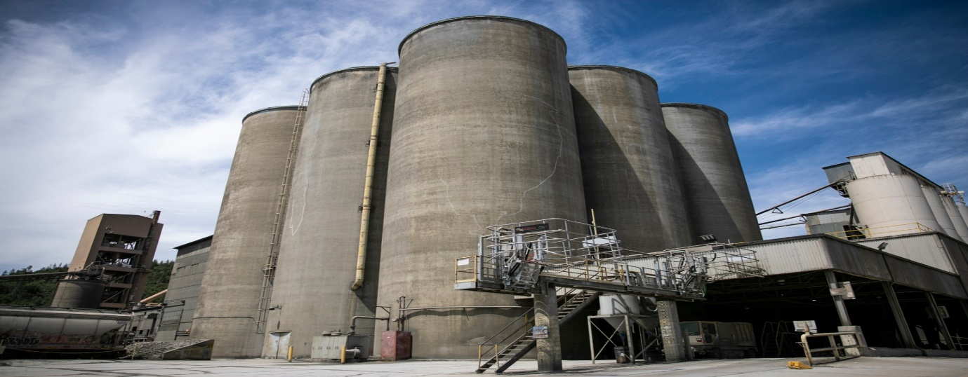

Fig 4: Industrial Structure ***(Arch Daily)***

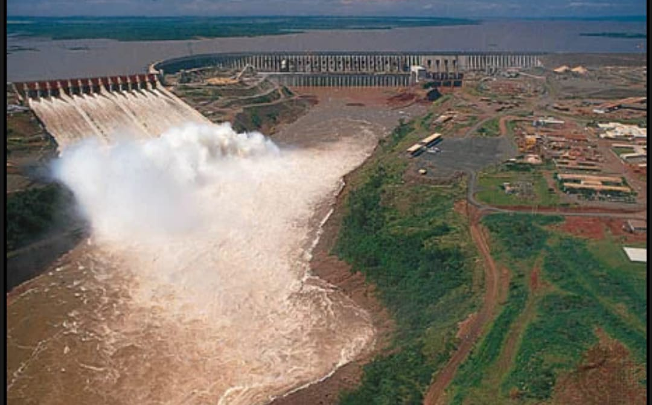***Dams and Reservoirs:*** In the construction of dams and reservoirs, where water pressure and structural stability are critical, high-strength concrete is employed to create durable structures that can withstand the immense forces exerted by large volumes of water.

Fig 5: Dams and reservoir ***(Enclyopedia Britannica)***

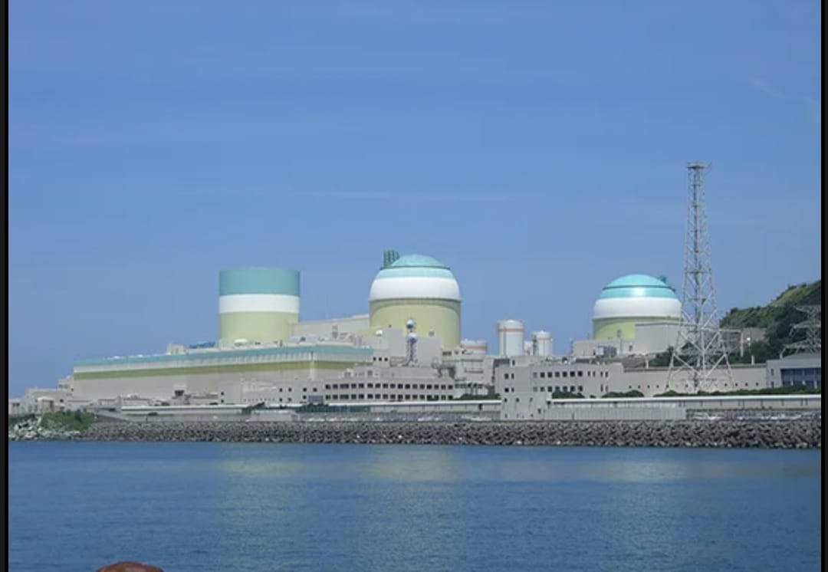***Marine Structures:*** Structures situated in marine environments, such as ports, docks, and coastal defences, face challenges from saltwater exposure and wave impact. High-strength concrete provides the necessary durability and resistance to environmental degradation in these demanding settings.

Fig 6: Marine structure ***(Enclyopedia Britannica)***

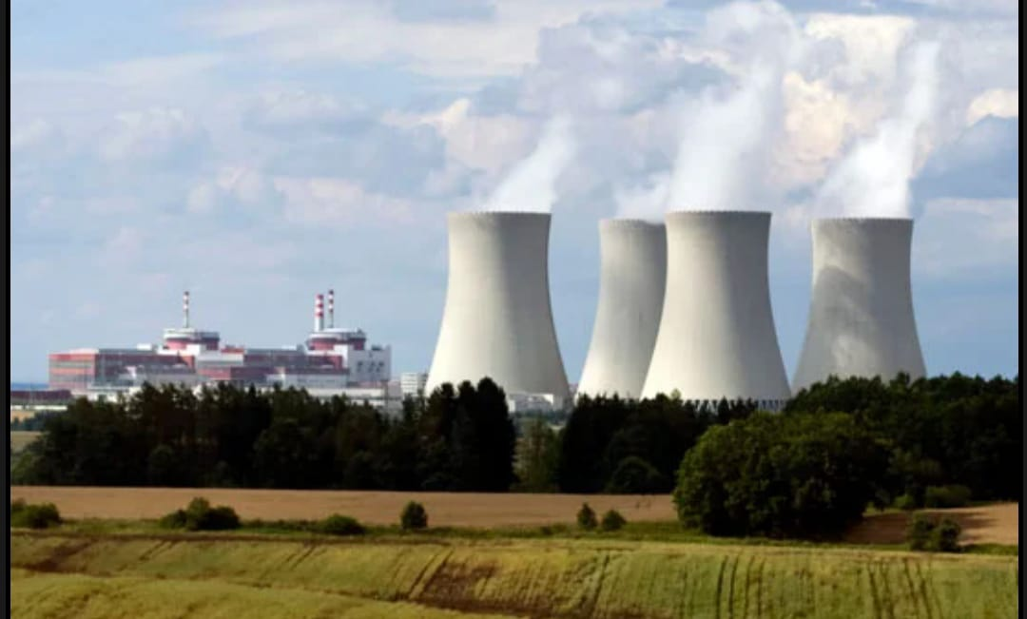***Nuclear Power Plants:*** The construction of nuclear power plants demands materials with high strength and resistance to radiation. High-strength concrete is utilized in the design of reactor structures and containment buildings to ensure the safety and longevity of nuclear facilities.

***Fig 7:*** Powerplant ***(Arch Daily)***

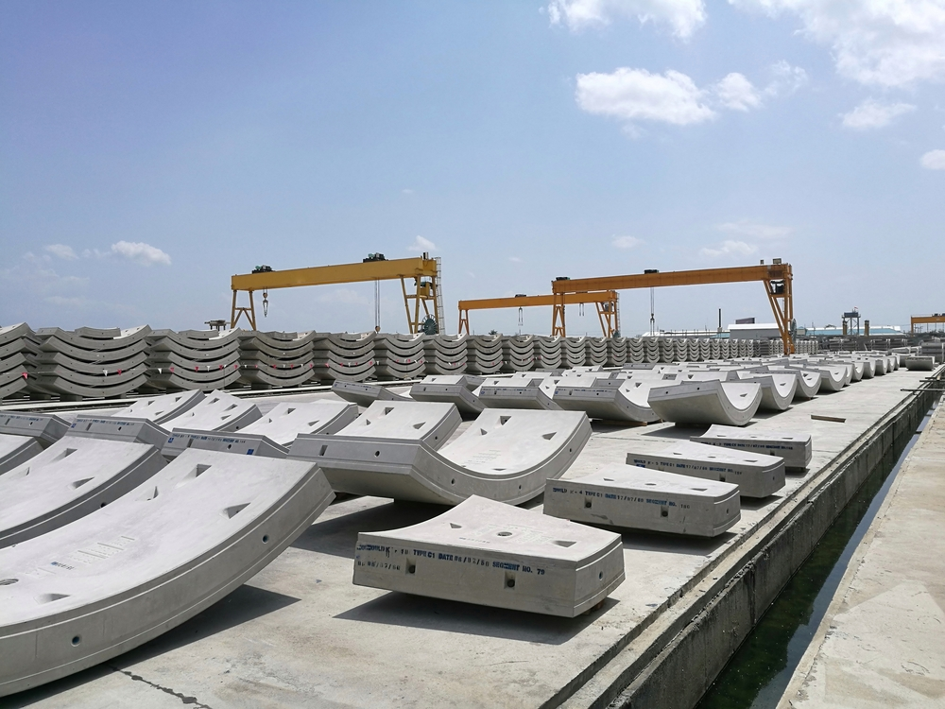***Precast Concrete Elements:*** High-strength concrete is often employed in the production of precast concrete elements, such as beams, columns, and panels. These precast components offer the advantage of high strength and consistency, facilitating efficient construction processes and ensuring uniform quality in the finished structures.

Fig 8: Precast concrete elements ***(Arch Daily)***

**1.8 Advantages of High Strength Concrete**

***Increased Load-Bearing Capacity:*** High-strength concrete excels in supporting heavy loads, making it particularly well-suited for structures with substantial weight requirements, such as tall buildings and bridges.

***Reduced Material Requirements:*** The enhanced strength of high-strength concrete allows for the use of smaller cross-sections in structural elements, resulting in a reduction in the overall volume of concrete required for construction projects.

***Enhanced Durability:*** High-strength concrete typically exhibits lower porosity, translating to increased resistance against environmental factors like water infiltration, chemical exposure, and the detrimental effects of freeze-thaw cycles.

***Improved Structural Performance:*** Structures constructed with high-strength concrete often experience minimal deformation under heavy loads, contributing to improved long-term performance and structural stability.

***Optimized Space Utilization:*** The heightened strength of the concrete enables the design of more slender and efficient structural elements, maximizing the effective use of space in architectural applications.

***Potential for Thinner Sections:*** High-strength concrete's ability to withstand higher stresses allows for the design of thinner structural sections,contributing toa more streamlined and aesthetically pleasing architectural design.

***Reduced Construction Time:*** The accelerated early strength development of high-strength concrete can expedite construction schedules, leading to faster project completion compared to projects utilizing conventional concrete.

***Better Resistance to Fire:******Advantages:*** High-strength concrete can exhibit enhanced resistance to fire, providing an additional layer of safety in structures where fire resistance is a critical consideration.

***Increased Design Flexibility:*** Engineers benefit from greater flexibility in designing intricate and innovative structures due to the superior strength characteristics of high-strength concrete.

***Long-Term Cost Savings:*** Despite the potentially higher initial cost, high-strength concrete can offer long-term cost savings through reduced maintenance requirements and an extended service life compared to standard concrete.

***1.9 Disadvantage of High Strength Concrete***

***Higher Cost:*** The production of high-strength concrete often involves specialized materials and meticulous testing procedures, contributing to higher initial costs compared to conventional concrete.

***Sensitivity to Mixing and Curing:*** Achieving the desired strength requires precise control over the mixing and curing process, making high-strength concrete more sensitive and demanding in terms of construction practices.

***Complex Quality Control:*** Quality control measures for high-strength concrete are more intricate, necessitating rigorous testing and monitoring to ensure the material meets specified standards.

***Limited Availability of Materials:*** Some regions may face challenges in sourcing the specific materials required for high-strength concrete, impacting its availability for certain projects.

***Temperature Sensitivity:*** High-strength concrete can be more sensitive to temperature variations during curing, requiring careful attention to prevent issues such as thermal cracking.

***Reduced Workability:*** The lower water-cement ratio in high-strength concrete can result in reduced workability, making it more challenging to handle and place during construction.

***Compatibility Issues with Admixtures:*** Achieving compatibility with certain admixtures can be challenging, limiting the range of additives that can be effectively used in high-strength concrete formulations.

***Potential for Brittle Failure:*** While high-strength concrete is strong, it may exhibit a more brittle failure mode under certain conditions, impacting the material's ability to deform before failure.

***Learning Curve for Construction Teams:*** Construction teams may need additional training and expertise to work effectively with high-strength concrete, potentially introducing a learning curve.

***Environmental Impact:*** The production of high-strength concrete, particularly if it involves specialized additives, may have a higher environmental impact compared to the production of regular concrete.

***1.10 Factors Affecting Strength of Concrete***

The response of concrete to stress is not solely dictated by the type of stress applied. It also depends on various factors that collectively influence the porosity of different concrete components. These factors include the characteristics and proportions of materials in the concrete mix, the degree of compaction during construction, and the conditions under which the concrete is cured.

In terms of strength, a key factor is the relationship between the water-cement ratio and porosity. The water-cement ratio significantly influences the porosity of both the cement mortar matrix and the transitional zone between the matrix and coarse aggregate. Regardless of other variables, this ratio plays a crucial role in determining the overall porosity, and subsequently, the strength of the concrete.

To elaborate further, the water-cement ratio refers to the amount of water used in the concrete mix relative to the amount of cement. A higher water-cement ratio generally leads to increased porosity in the concrete, affecting both the paste and the transition zone. Higher porosity can weaken the concrete and reduce its durability.

Therefore, in concrete mix design and construction practices, careful consideration of the water-cement ratio is essential to achieve the desired strength and durability. Balancing this ratio effectively contributes to optimizing the porosity levels, enhancing the overall performance and longevity of the concrete structure.

***1.10.1 Characteristic and Proportioning of Materials***

The initial step in creating a concrete mix involves carefully choosing component materials and determining their proportions to achieve the desired strength. Various aspects influencing concrete strength are crucial in this process. It is important to note that in practical applications, many parameters in mixture design are interconnected, making it challenging to isolate their individual influences.

*A: Water cement ratio:* The relationship between water-cement (w/c) ratio and concrete strength is commonly attributed to the progressive weakening of the matrix due to increased porosity with higher w/c ratios. However, this explanation overlooks the impact of the w/c ratio on the strength of the interfacial transition zone. In low- and medium-strength concrete using normal aggregate, both the interfacial transition zone porosity and matrix porosity influence strength, establishing a direct correlation between w/c ratio and concrete strength.

Yet, in high-strength concrete with very low w/c ratios, the traditional relationship breaks down. At w/c ratios below 0.3, small reductions in the ratio yield disproportionately high increases in compressive strength.

*B: Air entrainment:* The porosity of the cement paste matrix is primarily influenced by the water-cement ratio during hydration. When air voids are introduced, either due to inadequate compaction or air-entraining admixtures, they increase porosity and reduce strength. The impact of air entrainment on strength not only depends on the water-cement ratio but also on cement content. In summary, higher cement content in high-strength concretes results in substantial strength loss with increased air entrainment, while low-strength concretes may experience minimal loss or even gain strength. This is crucial in mass-concrete mixture design. The effects on concrete response to stress stem from air's dual role: increasing matrix porosity harms strength, but enhancing workability and compatibility improves the interfacial transition zone, especially in low-water, low-cement mixtures, ultimately enhancing concrete strength. In cases of low cement content, when air entrainment accompanies a significant water content reduction, the adverse impact on matrix strength is outweighed by the beneficial effect on the interfacial transition zone.

*C: Aggregate:* In concrete technology, an excessive focus on the correlation between water-cement ratio and strength has led to challenges. The impact of aggregate on concrete strength is often overlooked, as aggregate strength is typically not a factor in normal strength concrete. With natural aggregates, the strength of the aggregate is significantly higher than the matrix and interfacial transition zone, except for lightweight aggregates. However, various aggregate characteristics, including size, shape, surface texture, grading, and mineralogy, can influence concrete strength. While these effects are often attributed to changes in the water-cement ratio, evidence suggests that other factors, such as the size, shape, surface texture, and mineralogy of aggregate particles, independently influence the interfacial transition zone and thus affect concrete strength. Altering the maximum size of well-graded coarse aggregate can have conflicting effects on concrete strength. Larger aggregate particles require less mixing water but may form a weaker interfacial transition zone with more microcracks.

*D: Mixing water:*The presence of impurities in the water used for mixing concrete can impact not only the concrete strength but also affect setting time, result in efflorescence (white salt deposits on the concrete surface), and contribute to the corrosion of reinforcing and pre-stressing steel. Typically, water quality is not a primary factor in concrete strength, as specifications often require water fit for drinking. Municipal drinking waters usually stay below 1000 ppm dissolved solids.

However, water unsuitable for drinking may still be suitable for concrete mixing. Slightly acidic, alkaline, salty, brackish, coloured, or foul-smelling water should not be rejected outright, especially considering water scarcity worldwide. Recycled waters from urban areas, mining, and various industries can be safely used.

*E: Admixtures:* The impact of air-entraining admixtures on concrete strength has been previously addressed. Water-reducing admixtures, on the other hand, can improve both early and ultimate strength by lowering water content in a concrete mix while maintaining consistency. In scenarios with a constant water-cement ratio, the presence of water-reducing admixtures tends to positively influence cement hydration rates and early strength development. Admixtures that accelerate or retard cement hydration play a significant role in the rate of strength gain, though the ultimate strengths may not be markedly affected.

Researchers have observed a trend toward higher ultimate strength in concrete when the early strength gain is deliberately slowed. The growing use of pozzolanic and cementitious by-products as mineral admixtures in concrete, driven by ecological and economic considerations, is notable. When these mineral admixtures partially replace Portland cement, they often exhibit a retarding effect on early-age strength. However, their capacity to react with calcium hydroxide in hydrated Portland cement paste at normal temperatures, forming additional calcium silicate hydrate, can substantially reduce porosity in both the matrix and interfacial transition zone.

***1.10.2. Curing Conditions***

Concrete curing involves optimizing the conditions that facilitate cement hydration, namely the interplay of time, temperature, and humidity immediately after pouring a concrete mix into Molds. The porosity of the resulting hydrated cement paste, given a specific water-cement ratio, is influenced by the extent of cement hydration. When water is introduced to Portland cement under standard temperatures, initial hydration reactions commence, but their pace significantly diminishes as hydration by-products coat the dry cement particles. This slowdown occurs because optimal hydration requires saturated conditions, and the process nearly halts when the vapor pressure of water in capillaries drops below 80 percent of saturation humidity. Consequently, time and humidity emerge as crucial factors in the hydration process, primarily governed by water diffusion. In addition, akin to most chemical reactions, temperature plays a pivotal role, acting as a catalyst that accelerates the pace of hydration reactions

*A: Time:* The relationships between time and strength in concrete technology typically consider conditions involving moisture and normal temperatures. When moist curing is extended at a constant water-cement ratio, strength tends to increase because the hydration process of cement particles continues. However, in thin concrete elements where water evaporates from capillaries, air-curing conditions occur, and strength does not improve over time. This is due to the absence of sustained moisture needed for ongoing hydration.

*B: Humidity:* The rate of water loss from freshly placed concrete is influenced not only by the surface/volume ratio of the concrete element but also by temperature, relative humidity, and air velocity. A minimum 7-day moist-curing period is generally recommended for concrete containing normal Portland cement. For concrete mixtures with blended Portland cement or mineral admixtures, a more extended curing period is advisable to ensure strength contribution from the pozzolanic reaction.

Moist curing can be achieved through methods such as spraying, bonding, or covering the concrete surface with wet sand, sawdust, or cotton mats. Given that the mixing water used in concrete often exceeds what is necessary for Portland cement hydration, the proper application of an impermeable membrane shortly after placement helps maintain satisfactory strength development. However, when controlling cracking due thermal shrinkage is crucial, moist curing should be the preferred method

*C: Temperature:* A higher casting and curing temperature correlate with lower ultimate strength. The time-temperature history's influence on concrete strength holds significance in construction practices. Maintaining a minimum curing temperature is crucial for the strength of concrete placed in cold weather, with curing temperature outweighing placement temperature importance.

Concrete cured in warmer climates tends to exhibit higher early strength but lower ultimate strength compared to counterparts cured in colder conditions. In precast concrete, steam curing accelerates strength development for faster Mold release. Uncontrolled temperature in massive elements can result in concrete retaining a higher temperature than the environment for an extended period. Consequently, in-situ concrete strength is higher in early ages and lower in later ages compared to specimens cured at standard laboratory temperature.

*3. Degree of Compaction:* Compaction significantly influences compressive strength, exemplified by concrete with 10% entrapped air having a mere 50% strength compared to fully compacted concrete. This effect extends to permeability, as compaction not only eliminates entrapped air but also ensures a more uniform pore distribution, making them discontinuous and reducing concrete permeability, ultimately enhancing durability.

Moreover, compaction plays a pivotal role in improving abrasion resistance on concrete surfaces. Adequate compaction typically enhances this resistance. Yet, a delicate balance is crucial, as excessive vibration or surface work can lead to an accumulation of excess mortar and moisture at the surface, diminishing potential abrasion resistance. In flatwork, achieving the right equilibrium is essential to expel entrapped air without introducing excessive mortar to the concrete surface.

**Chapter 2**

**Literature Review**

**2.1 Introduction**

This chapter is focused on the literature review of studies associated with High strength concrete. Assessment of physical, mechanical, and chemical properties of high strength concrete.

**2.2 Work Done so far**

*Sernas et al. (2020)* investigated, how adding silica fume, a mineral admixture, to high-strength concrete affects its performance for road pavement. Three concrete mixtures with different silica fume amounts (0%, 7%, and 10%) were tested. The results indicate that silica fume improves concrete strength in compression, tension, bending, and cyclic loading. The optimal amount appears to be 7% to gain best results.

The research shows that adding silica fume to high-strength concrete significantly improves its performance in compression, tension, bending, and fatigue resistance. This is because silica fume reacts with cement, creating a denser microstructure in the concrete. The study suggests that 7% silica fume is optimal, resulting in 37%, 16%, and 35% higher strength in compression, tension, and bending, respectively, along with 45% higher fatigue resistance. Going beyond 7% does not significantly improve compressive strength, and it slightly decreases tensile and flexural strength. The study emphasizes that the right amount of silica fume depends on the specific particle size distribution of the concrete.

*Thaguna et al. (2023)* explored utilization of waste marble dust powder as a substitute for sand in concrete production to enhance sustainability. Experiments showed that replacing up to 30% of sand with marble dust increased concrete strength, but beyond that, strength decreased. Workability decreased with higher marble dust percentages due to increased fineness and water demand. Compressive, flexural, and tensile strengths generally improved, except at 60% replacement where strengths decreased compared to normal concrete. Overall, using marble dust not only strengthens concrete but also helps reduce environmental pollution and natural resource consumption. Adding marble dust powder to concrete reduces its workability, likely due to the finer particles requiring more cement and water for hydration. The best compressive strength was at 30% marble dust replacement for sand, exceeding normal concrete by about 23%. However, strength declined at 60% replacement, dropping below normal concrete by around 25%. The highest tensile strength was also at 30% replacement, showing a 13% increase, but it decreased at 60%. Similarly, the greatest flexural strength was at 30%, with an increase of about 28%, but at 60%, it decreased by around 3%. In summary, a 30% replacement is recommended for optimal strength without compromising workability, and plasticizers may be needed for better workability when using higher amounts of marble dust.

*Memy and Fani (2017)*This study explored using waste marble from landfills as an eco-friendlier solution. They dried and sifted the marble sludge, then replaced varying amounts of cement with it (0%, 5%, 10%, 15%, 20%). Testing 75 concrete cubes revealed that 5% replacement enhanced compressive strength by around 10%, while 10% replacement showed similar results. However, higher marble dust proportions reduced the workability of fresh concrete, with 10% replacement significantly impacting it. Overall, 5% replacement seemed to strike a balance between strength and workability.

The study suggests that the workability of concrete significantly decreases, indicating a need for appropriate plasticizers. However, there is a positive finding that replacing 5% of cement with Marble Dust boosts the 28-day compressive strength by up to 10%. This leads to the conclusion that 5% replacement is the optimal content for substituting cement with marble powder. In essence, it strikes a balance between improving strength and maintaining reasonable workability.

*Singh and Kumar (2023)* further investigated the influence on mechanical properties, when cement is replaced with marble dust. This Study explore replacing cement with materials like marble dust in concrete production. Traditional cement production emits harmful gases, contributing to pollution. Using industrial waste, such as marble dust, in concrete not only enhances durability but also reduces natural resource consumption and pollution. This study focuses on substituting marble dust for cement in M20 grade concrete, evaluating factors like compressive strength after 7 and 28 days and workability. The aim is to achieve an eco-friendly and cost-effective alternative, considering the positive impacts on both strength and environmental sustainability.

In the experiment, marble powder and a super plasticizer were tested as construction materials. Concrete cubes were made with different amounts of marble powder replacing cement, and the impact on compressive strength and slump values was observed. The best results were seen with 15% cement replacement and 1.5% super plasticizer, showing the highest compressive strength compared to other replacement percentages (5%, 10%, and 20%). Additionally, the slump values increased gradually with higher cement replacement, reaching 130 mm at 15% replacement, indicating improved workability in the concrete mix.

*Ali et al. (2021)* explores use of recycled materials from demolished buildings in Iraq and crushed concrete cubes from the laboratory to make eco-friendly concrete. They replaced natural aggregates with recycled ones at different percentages (0%, 33.3%, 66.7%, and 100%) and added silica fume as an improvement. The results revealed that recycled concrete from demolished buildings had lower strength, while recycled cubes from the lab had higher strength compared to regular concrete. Adding silica fume increased strength in all recycled concretes. The ease of working with recycled aggregate concrete decreases as the percentage of recycled coarse aggregate increases, while keeping cement and water constant. Adding silica fume to recycled aggregate concrete increases the water needed to maintain the same workability.

Concrete made from waste coarse aggregate showed a gradual strength decrease with higher replacement percentages, while concrete from recycled aggregate exhibited a strength increase. Silica fume further increased strength, surpassing that of regular concrete. Tensile strength decreased with waste coarse aggregate but increased with recycled aggregate, especially with silica fume, except at 100% replacement.

*Sathiaseelan et al. (2022)* investigated the fly ash as potential replacement of cement. Study suggested that the use of fly ash instead of some cement in concrete has become popular for cost-effective disposal of thermal station by-products. The impact on concrete depends on factors like cement type, replacement percentage, environment, and curing time. Studies show that with the right proportion, low calcium fly ash enhances concrete strength over 28 to 56 days and improves its flow properties. Using fly ash as a cement substitute is a cost-effective and lasting solution for concrete. Adding 10% fly ash to cement increases the compacting factor by 4% for every 10% addition. Workability decreases if fine aggregate is replaced with more than 8% fly ash and becomes unworkable at over 40%. Fly ash lowers compressive and early strength in high-grade concrete but is cost-effective for such concrete with a high fly ash percentage. High percentage of low calcium fly ash makes concrete permeable to chloride ions, has low dilatation, and better durability. High calcium fly ash affects concrete strength development at later ages, with a 6.2 to 16% strength increase between 28 to 56 days. Replacing 10% of cement with fly ash increases the compacting factor by 4%

*Kingsluy and Adinna (2023)* aimed to enhance concrete strength and workability by using less water. They added fly ash, replacing some cement, and quarry dust, replacing some fine aggregate. Superplasticizer (SNFC) was included to reduce water content. Tests showed improved compressive strength (19.58N/mm² to 30.23N/mm² at 28 days) compared to regular concrete. The recommended mix involves fly ash, quarry dust, and SNFC to address low-strength concrete issues.

Adding fly ash and a superplasticizer (SNFC) to concrete boosts workability, especially up to 10% replacement of cement with fly ash. Quarry dust improves compressive strength but reduces workability. However, combining quarry dust, fly ash, and superplasticizer creates highly workable, high-strength concrete. Using quarry dust and superplasticizer together results in very strong and workable concrete, with the superplasticizer improving workability and quarry dust enhancing strength.

*Uinhquang and Bulgakov (2023); t*his research aimed to create high-performance concrete (HPC) suitable for the country's climate and conditions, given its vulnerability to climate change and sea level rise. Using local materials like special cement, crushed granite, river sand, and additives, they designed concrete mixes following standards. After various testing periods, the best results were HPC mixes with specific combinations of fly ash and silica fume, exceeding 110 MPa compressive strength. The study highlights those locally available materials, with careful selection and mixing, can produce strong and durable concrete for construction challenging environment. This study in Vietnam created strong and durable concrete using local materials. By replacing some cement with industrial by-products like fly ash and silicafume, they achieved high-performanceconcrete with a strength of 85 to 105 MPa at 56 days. The best mix had a specific combination of water, cementitious material, fly ash, and silica fume. A 10% replacement of silica fume with 20-40% fly ash proved to be the optimal choice for top-notch concrete properties.

*Mishra and Krleong (2017)* explored a new type of eco-friendly concrete, known as green concrete, has been developed by replacing 80% of traditional cement with fly ash. This not only reduces costs but also minimizes energy use and carbon emissions. Green concrete offers better durability and strength compared to regular concrete. This development is crucial because cement production is a major source of global greenhouse gas emissions, particularly in China and India. However, safe disposal of fly ash in these countries remains a challenge. To make this environmentally friendly concrete more accessible in India, the target strength can be lowered to 30 MPa, allowing for increased fly ash content

They studied a new type of eco-friendly concrete, called ultra-high volume fly ash (UHVFA) concrete. By lowering the water/binder ratio and carefully combining materials, they created UHVFA concrete with good strength (over 40 MPa at 7 days, over 60 MPa at 28 days) suitable for structural use, even with 80% of the cement replaced by fly ash. This green concrete reduces environmental impact and material cost significantly compared to regular concrete. It cuts CO2 emissions by around 70%, lowers embodied energy by over 60%, and decreases material cost by about 15%. The findings are relevant for India, and the study suggests future research directions to maximize the use of fly ash generated in the country.

*Balestra et al. (2018)* investigated the influence of curing condition on strength of concrete.How different curing conditions affect the strength of concrete over a year. They tested five curing methods and used statistical tests to analyze the data. The key finding is that curing conditions significantly impact concrete strength, but mainly after 28 days. Concrete soaked in water showed the highest strength, surpassing that cured in a standard moist chamber. Strength decreased in the following order: water tank, moist chamber, tank with water and lime, laboratory environment, and external environment. The study also noted varying strength gain over time for each condition, with the external environment showing the lowest values due to difficulties in controlling water loss.

This paper shows that how you cure concrete affects its strength. The impact is more noticeable after 28 days. The strength decreases in this order: water tank, moist chamber, tank with water and lime, laboratory environment, and external environment. For internal and external cures, strength gain between 7 and 28 days is lower, spreading evenly over a year. Other conditions show more strength gain in the first 28 days. External conditions have the lowest values due to difficulty controlling water loss. The study suggests careful curing control for better concrete strength. It emphasizes that in real construction, where environmental conditions are hard to control, curing conditions need attention for satisfactory results. The paper highlights that fully saturating concrete in water leads to better compressive strength.

A review study has been conducted by *Rashida and Mansur (2008)* to combine all high-strength concrete (HSC) formation techniques. It emphasizes using quality materials, less water, more coarse aggregate, smaller size of coarse aggregate, and specific admixtures. The experimental study aimed for strengths between 60 MPa to 130 MPa, considering factors like water-binder ratio and superplasticizer-binder ratio. Results confirm the importance of low water-binder ratio and optimal admixture levels in producing HSC, highlighting them as key factors. Making high-strength concrete (HSC) is trickier than regular concrete. It needs top-quality materials and precise proportions. The key is to reduce tiny pores and boost the bond between cement and aggregate. This is done by using less water, adding ultra-fine particles like silica fume, but without sacrificing workability. The table in the paper outlines ingredient requirements and essential considerations for producing HSC. Even with standard materials, HSC with strengths up to 127 MPa is possible, but a crucial factor is using less water and including a superplasticizer.

*Gupta et al. (2009)* investigated the shrinkage behaviour of High Strength Concrete (HSC) made with fly ash and silica fume. Different aggregates were used, and the concrete mix had specific proportions. Results showed that as HSC ages, its shrinkage increases. Concrete with fly ash and silica fume had higher shrinkage than without. Using Badarpur sand resulted in slightly less shrinkage than with Yamuna sand. Also, using granite as coarse aggregate caused slightly less shrinkage than using sandstone. Overall, HSC had less shrinkage than regular concrete.

The test results lead to several conclusions: Firstly, concrete experiences increased shrinkage strain over time. Secondly, when 10% of cement is replaced with fly ash and silica fume, the concrete shows higher shrinkage strains (6 to 10%) compared to concrete without these additives. Thirdly, using Badarpur sand as fine aggregate results in slightly less shrinkage strain (10%) at 90 days than when using Yamuna sand. Lastly, with granite as coarse aggregate, the shrinkage strain at 90 days is marginally less (7%) than with sandstone aggregate. In essence, these findings highlight the influence of time, material replacements, and aggregate types on concrete shrinkage.

*Safiuddin et.al (2009)* conducted a study to highlights the crucial role of ingredients in achieving high strength and durability. It stresses the importance of adding high-range water reducers and air-entraining admixtures for workability and freeze-thaw durability. The focus is on the right amounts of these materials for optimal performance, discussing their impact on both fresh and hardened properties, as well as the overall durability of HSHPC.

The performance and durability of high-strength high-performance concrete (HSHPC) depend on its constituent materials. Coarse and fine aggregates influence workability, strength, and durability. Cement contributes to workability, strength, and water tightness. Supplementary cementing materials impact workability and enhance hardened properties and durability. Water lubricates aggregates, improving workability and contributing to strength and durability. High-range water reducer enhances workability, strength, and durability by reducing mixing water. Air-entraining admixture improves freeze-thaw durability and workability. Properly selecting and using these materials is crucial for optimal HSHPC performance.

A codal provision-based study has been conducted by *Patil and Kapali (2018)* The study aims to create strong concrete without additives like GGBS or silica fume, following guidelines from the Concrete Bridge Code-1997. A new superplasticizer reduces the water-cement ratio, crucial for concrete strength, by filling gel pores, potentially eliminating 15% of water used for this purpose. This study explores making strong concrete (grade M55) using less water by adding a Superplasticizer and Silica Fume. Interestingly, replacing 10% of cement with Silica Fume lowers strength, but a 5% increase improves it by 6.0%. The best strength comes with a 15% cement replacement. Less water (lower ratio) increases strength by 6.5%, with the best ratio at 0.25. M55 concrete can be made without Silica Fume, saving costs. A modern Superplasticizer helps achieve high strength, low permeability, and durability. This method follows IS 456:2000 standards.

**Chapter 3**

**Research Gap**

* The cost of high strength concrete construction is much more expensive. There has not been much exploration on the cost optimization aspects.
* There are no specific optimal ratios of the concrete mix to achieve maximum strength and enhance the properties of concrete.
* There is a lack on nondestructive testing techniques for assessing the quality in performance of high strength concrete.
* There is not much technique in methods of quality control and monitoring of high strength concrete during construction to ensure consistency any reliability.
* There is no standardize mixed proportioning technique available for high strength concrete, only trial and error method are employed.
* Weight of high strength is high as compare to normal strength concrete. The development of light weight concrete is ongoing for normal strength concrete. Furter, development of high strength light weight concrete can be considered as potential research gap.
* There has not been much exploration on the use of waste material such as recycle aggregates or industrial by products in high strength concrete.
* There is not much exploration on the use of alternative materials and producing methods to reduce the impact of environment.

**Chapter 4**

**Future work and conclusion**

**4.1 Work to be done**

* To learn the effect of admixtures on the development of high strength concrete
* To study the factors affecting the strength of concrete
* To achieve a concrete mix of strength greater than 80 Mpa

**4.2 Conclusion**

In summary, our high strength concrete project filled a gap in our knowledge about construction materials by focusing on making concrete tougher. We saw the need for stronger and more durable buildings and learned how to improve concrete mixtures using advanced materials.

Finding this gap showed us why it is crucial to keep exploring and innovating in construction materials. Even though our project did not give results, it set our goal for future research. By recognizing the gap, we dig deeper into high-strength concrete, to find better and more eco-friendly solutions.

In simple terms, our project matters not just for what we found now but for inspiring us for further research and improvement in how we understand and make materials for long-lasting and strong buildings. Looking ahead, we plan to keep addressing these gaps to boost our knowledge and enhance the performance of materials that are crucial for sturdy and resilient infrastructure.

**Reference**

* Junior, R. A., M. G. Lima, and Carlos Eduardo Tino Balestra. "Influence of Distinct Curing Environments on the Compressive Strength of Concrete." Journal of Engineering, Project, and Production Management 8, no. 2 (2018): 56.
* Mishra, Dhanada Kanta, Jing Yu, and Christopher Kin Ying Leung. "Very high-volume fly ash green concrete for application in India." Global Waste Management (2017): 480.
* Gražulytė, Judita, Audrius Vaitkus, Ovidijus Šernas, and Donatas Čygas. "Effect of silica fume on high-strength concrete performance." In 5th World Congress on Civil, Structural, and Environmental Engineering (CSEE’20), vol. 162, pp. 1-6. 2020.
* Themisana, Rajkumari & Thakur, Abhilash & Thaguna, Parwati & Thounaojam, Anuradha & Senagah, Amenjor. (2023). TO DETERMINE THE STRENGTH OF CONCRETE WITH PARTIAL REPLACEMENT OF SAND WITH MARBLE DUST POWDER. 10.17605/OSF.IO/QD68N**.”**
* Memon, F. A., A. M. Yousfani, D. K. Ladher, and N. Jarwar. "Effect of Marble Dust as a Partial Replacement of Cement on Fresh and Hardened Properties of Concrete." In Proceedings of the International Conference on Sustainable Development in Civil Engineering, Jamshoro, Pakistan, pp. 23-25. 2017.
* Ludovic, V. S., R. V. Lesovik, and WS Albo Ali. "Effect of recycled coarse
* aggregate from concrete debris on the strength of concrete." In Journal of Physics: Conference Series, vol. 1926, no. 1, p. 012002. IOP Publishing, 2021.
* Obi, Okechukwu K., and Okafor B. Adinna. "Strength and Workability of Concrete with Inclusion of Fly Ash, Quarry Dust and a Generic Naphthalene-based Superplasticizer." (2023).
* Bulgakov, B. I., V. Q. D. Nguyen, A. V. Aleksandrova, O. A. Larsen, and N. A. Galtseva. "High-performance concrete produced with locally available materials." Magazine of Civil Engineering 1 (117) (2023).
* Rashid, Mohammad Abdur, and Mohammad Abul Mansur. "Considerations in producing high strength concrete." Journal of Civil Engineering (IEB) 37, no. 1 (2009): 53-63.
* Gupta, S. M., V. K. Sehgal, and S. K. Kaushik. "Shrinkage of high strength concrete." International Journal of Mechanical and Mechatronics Engineering 3, no. 2 (2009): 154-157.
* Sathiaseelan, Brindha & Hannahangelin, Mrs & Sathiaseelan, P & Affiliations, Author. (2022). Fly Ash as Mineral Admixture in Concrete Matrix -A State of the Art. Journal of Environmental Protection and Ecology.
* Kumar, Rahul & Singh, Neha. (2023). Experimental Analysis of Partial Replacement of Ordinary Portland Cement in Concrete with Super plasticizer and Marble Dust. International Research Journal of Engineering IT & Scientific Research. 09. 527.
* Safiuddin, Md & Islam, Md & Zain, M. & Mahmud, Hilmi. (2009). Material aspects for high-strength high performance concrete. International Journal of Mechanical and Materials Engineering.
* Patil, Poornima & A, Kushal. (2018). High Strength Concrete without using Cementitious Admixtures. International Journal of Engineering Research and. V7. 10.17577/IJERTV7IS0100.